Steps to include graphics.h in CodeBlocks:
Step 1: You can find these files from another folder which is placed just above this word file i.e. WinBGIm_Library6_0_Nov2005
- graphics.h
- winbgim.h
- libbgi.a
Step 2: Copy and paste graphics.h and winbgim.h files into the include folder of your compiler directory. (If you have Code::Blocks old version installed like 17.12 in C drive of your computer, go through: Disk C >> Program Files >> CodeBlocks >> MinGW >> include. Paste these two files there.
OR if you have new version installed like 20.03 in your C drive of your computer then go through :Disk C>> Program Files >> CodeBlocks >> MinGW>> x86_64-w64-mingw32>> include. Paste these two files there.)
Step 3: Copy and paste libbgi.a to the lib folder of your compiler directory.
Step 4: Open Code::Blocks. Go to Settings >> Compiler >> Linker settings.
Step 5: In that window, click the Add button under the “Link libraries” part, and browse and select the libbgi.a file copied to the lib folder in step 3.
Step 6: Go to “Other linker options” on the right part and paste these commands:
-lbgi -lgdi32 -lcomdlg32 -luuid -loleaut32 -lole32

Step 7: Make sure you got steps 6 and 7 right! Here’s a screenshot of previous two steps. Then, click Ok.

Step 8: If you now try compiling a graphics.h program code in C or C++, you’ll still get error. To solve it, open graphics.h file (pasted in include folder in step 3) with Notepad++. Go to line number 302, and replace that line with this line:

Save the file. Done!
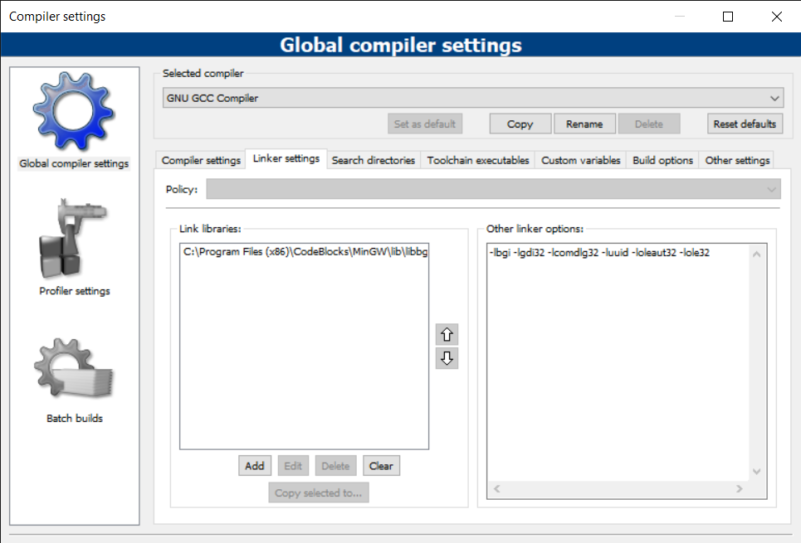Now you can compile any C or C++ program containing graphics.h header file. If you compile C codes, you’ll still get an error saying:
“fatal error: sstream : no such file directory”.
For this issue, if your file extension is .c, change it to .cpp.
For more info : http://winbgim.codecutter.org/

